HIGHLANDS Boys Tennis
2020 Schedule
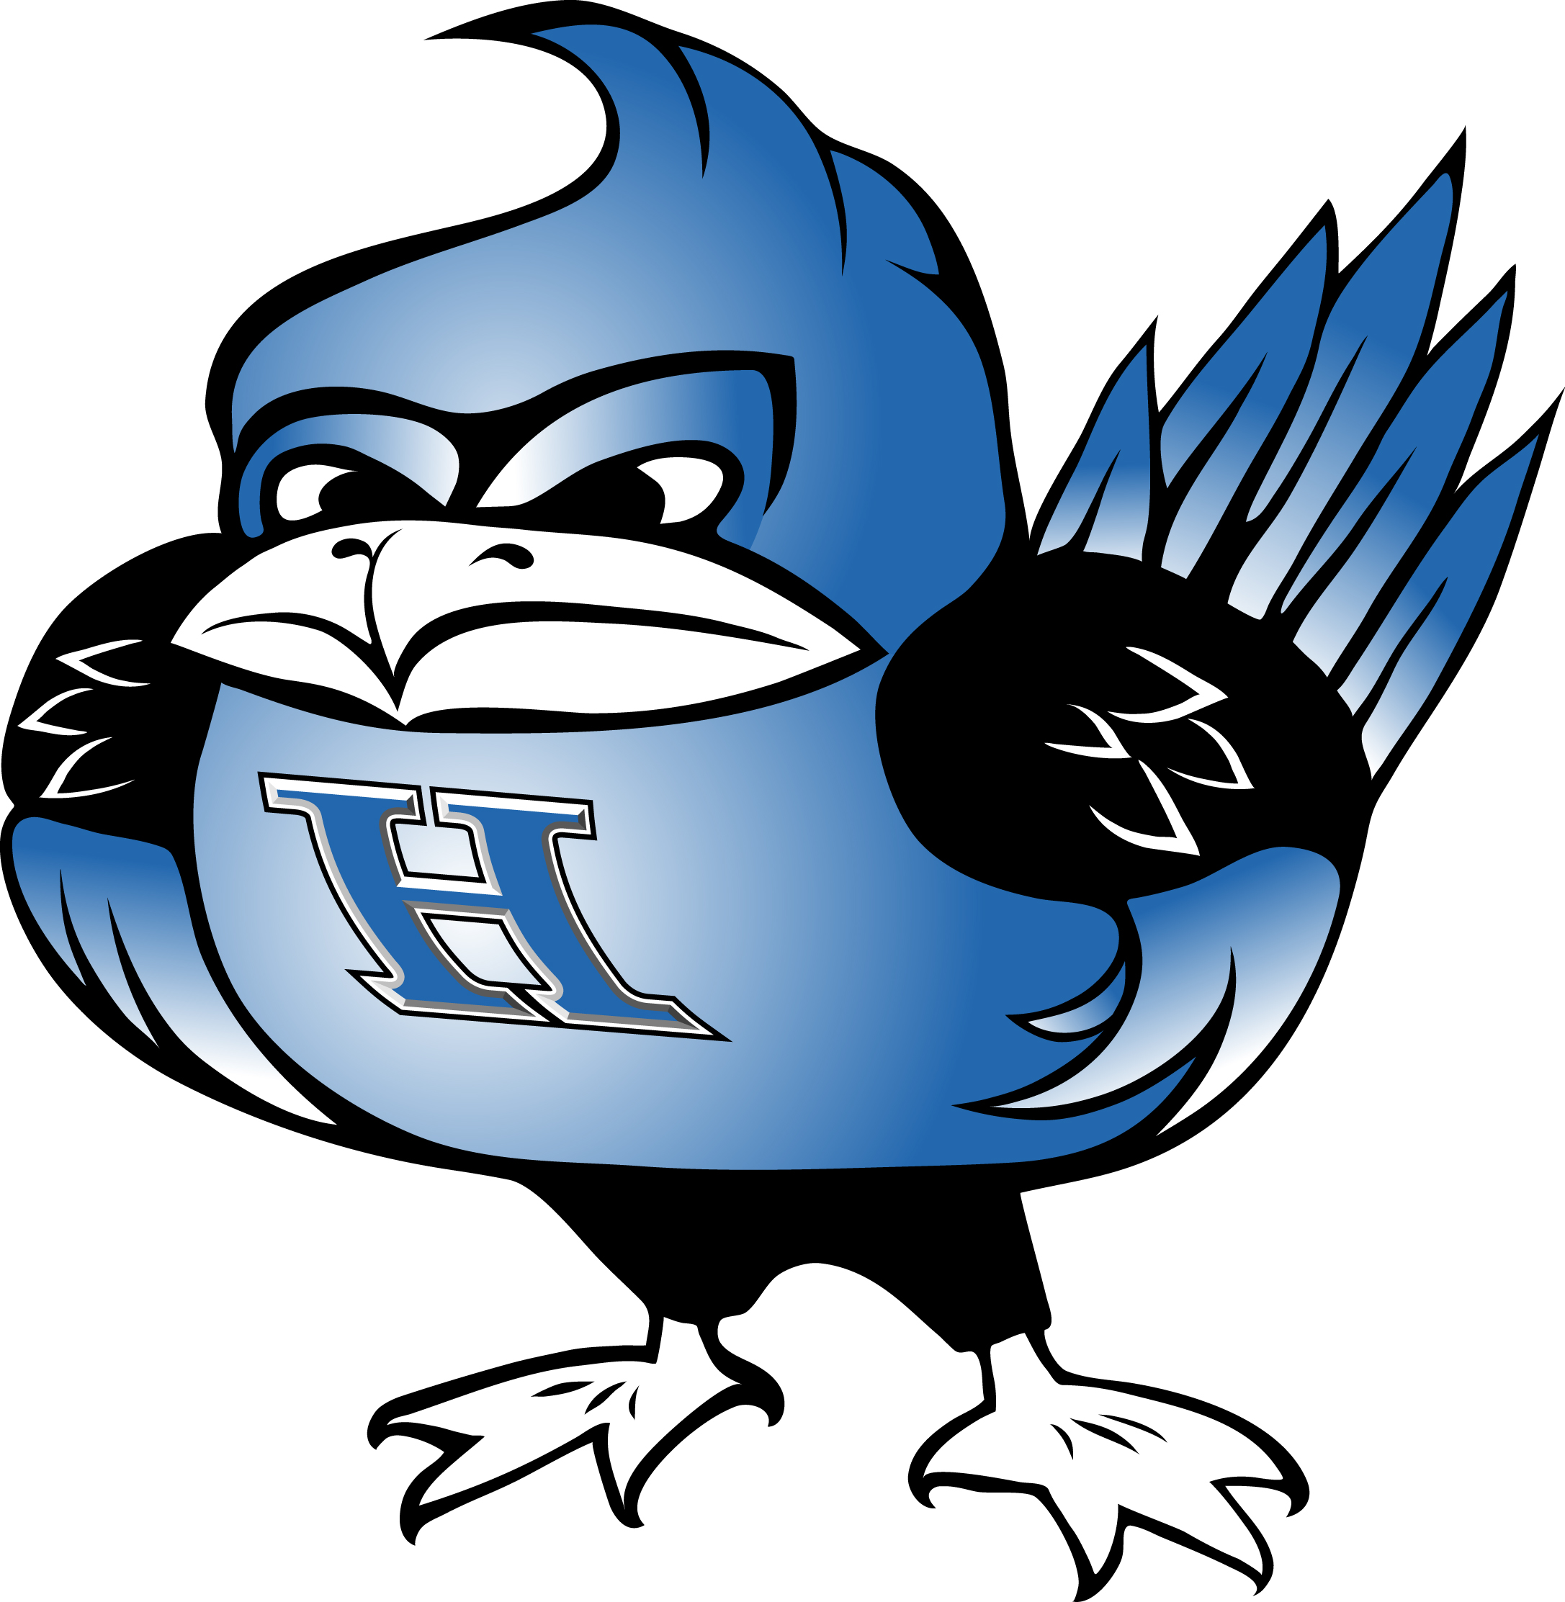
DATE | OPPONENT | LOCATION | TIME
3/9/2020 | Pendleton Co | Tower Park | 4:15pm | Varsity
3/12/2020 | Campbell County | Tower Park | 4:00 pm | JV only
3/16/2020 | Covington Catholic | Cov Cath | 4:00 pm | JV Only
3/19/2020 | Cooper | Tower Park | 3:45 pm | Varsity
3/25/2020 | Ryle | Tower Park | 3:30 PM | Varsity/JV
3/26/2020 | Conner | Boone Woods | 3:30 PM | Varsity
3/27/2020 | NKAC Tourn | Tower Park | 3:45 PM | Varsity
3/28/2020 | NKAC Tourn | Tower Park | 10:00 am | Varsity
3/30/2020 | Cincinnati Hills Christian | CHCA | 4:00 pm | Varsity
3/31/2020 | St Henry | Richardson Rd | 4:00 pm | Varsity
4/2/2020 | Villa Madonna | Tower Park | 3:45pm | Varsity/JV
4/13/2020 | Harrison (OH) | Tower Park | 4:00 pm | Varsity
4/15/2020 | Campbell County | Tower Park | 3:45 pm | Varsity/JV
4/17/2020 | Beechwood | Tower Park | 3:45 PM | Varsity/JV
4/20/2020 | Covington Latin | Tower Park | 3:45 pm | Varsity
4/21/2020 | Walton Verona HS | Walton, KY | 4:15 pm | Varsity
4/22/2020 | Scott | Scott HS | 3:30 pm | Varsity
4/22/2020 | Simon Kenton | Simon Kenton HS | 5:30pm | Varsity
4/23/2020 | Villa Madonna | Tower Park | 3:30 pm | JV only
4/24/2020 | Harrison HS | Harrison, OH | 4:00 pm | JV Only
4/25/2020 | Morgan County | Campbell County | tba | Varsity
4/27/2020 | Covington Catholic | Tower Park | 3:30 pm | Varsity/JV
4/29/2020 | Anderson HS(OH) | Tower Park | 4:00 pm | Varsity
4/30/2020 | Newport Central Catholic | Tower Park | 3:30 pm | Varsity
5/4/2020 | Ryle | Ryle HS | 4:00 pm | Varsity
5/6/2020 | Tates Creek HS | Tates Creek HS | 5:30 pm | Varsity
5/8/2020 | NKY JV Tourney(tentative) | Campbell Co | 4-8pm | JV
5/9/2020 | Harrison HS | Tower Park | 9:30am | Varsity/JV
5/11/2020 | NKY JV Tourney(tentative) | Campbell Co | 4:00 pm | JV
5/11/2020 | Conner (Senior Day) | Tower Park | 3:30pm | Varsity
5/12/2020 | North Oldham | North Oldham | 5:30pm | Varsity
5/18-5/26 | 9th Region Tournament | Covington Catholic | TBD | VARSITY
6/1-6/3 | State Tournament | Nicholasville, KY | all day | state qualifiers
GO BIRDS!

